**TASK 5**

**Task 5:**

**SQL Queries and their outputs for questions in task 5.**

1. Write a query which would update the album duration: increase by 10 seconds the duration of all your CD albums.

SQL Query:

Update album

Set albumDuration = date_add(albumDuration, interval 10 second) ;

Select * from album;

Output:

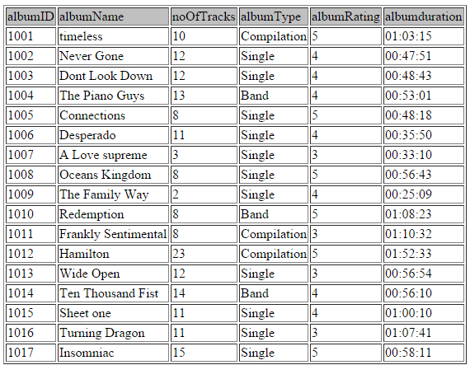

1. Write a query which would delete all albums that you bought in 2005, their condition is "poor" and cost less than $1.00.

SQL Query:

delete

from albumCollection

where left(purchaseDate,4)=2005 and albumCondition='Poor' and purchaseAmount<1.00;

1. Write a query which would delete the relation which stores the information about the artists.

SQL Query:

drop table artistCollection;

1. Write a query which would create an extra attribute in the appropriate relation. Give the name ‘classic’ to this attribute. The column then should be populated with data: values ‘true’ if the album was recorded before the year 1950 and ‘false’ if the album was recorded after 1950.

SQL Query:

Alter table Album

Add column Classic enum('True','False');

Update album as A

Join albumCollection as B

ON A.AlbumID = B.AlbumID

Set A.Classic = IF(B.recordDate > '1949-12-31', 'False', 'True');

Output:

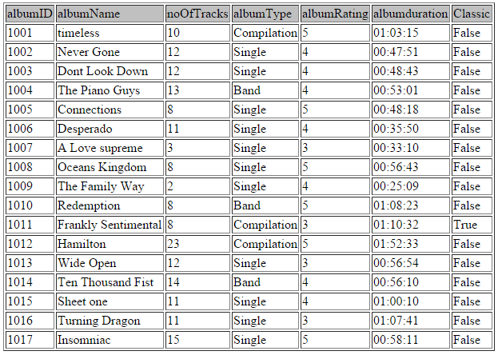

For 5, 6, 7 create three different VIEWS which will accommodate the three different requirements.

1. The album title with the money paid and its artist(s).

SQL Query:

Create View View1 as

Select A.AlbumName, D.ArtistName, B.PurchaseAmount

from album as A, albumcollection as B, artist as D, artistCollection as C

where A.albumID=B.albumID and B.albumID=C.albumID and C.artistID=D.artistID

Order by albumname, purchaseAmount,artistName;

Select * from View1;

Output:

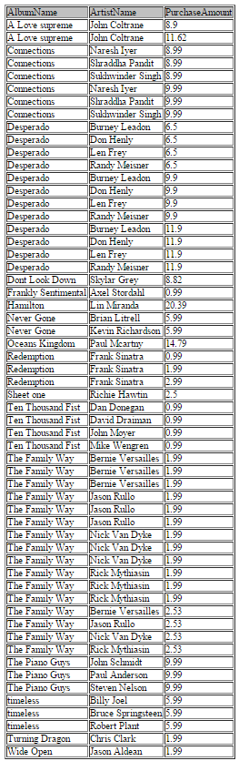

1. The album title with the music genre category and the condition.

SQL Query:

CREATE VIEW View2 AS

Select B.AlbumName, A.AlbumGenre, C.albumCondition

From Genre as A, album as B, albumcollection as C

Where A.AlbumID = B.AlbumID and B.AlbumID = C.AlbumID

Order By B.AlbumName;

Select * from view2;

Output:

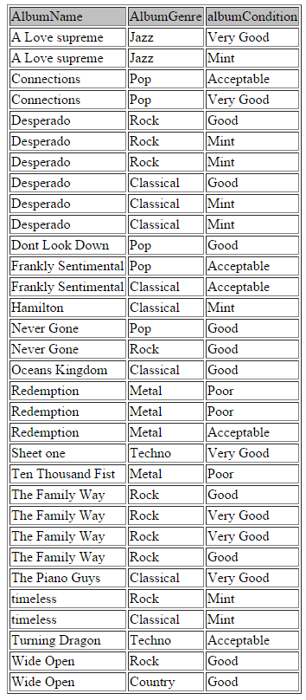

1. The average amount of money paid for each unique album (not counting duplicates),

SQL Query:

Create View View3 as

Select A.AlbumName, avg(B.PurchaseAmount) as AverageAmount

from album as A, albumcollection as B

where A.albumID=B.albumID

Group By A.albumName

Order by avg(B.PurchaseAmount);

Select * from View3;

Output:

